Go to VPC

Create VPC Peering Connection

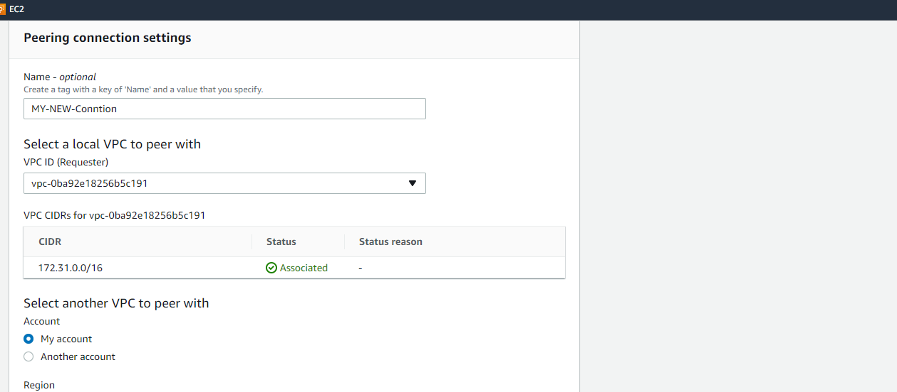

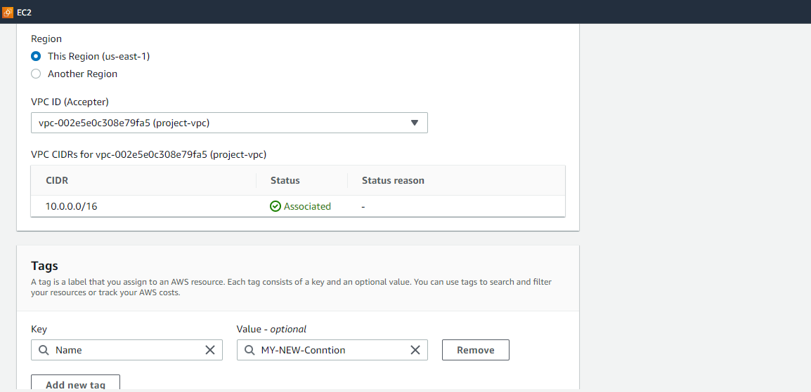

VPC > Create VPC Peering > VPC ID (Requester) SELECT > My account > This region > create

**To request a VPC peering connection with a VPC in another account in the same Region**

VPC > Create VPC Peering > VPC ID (Requester) SELECT > Another account > Account ID > This region > VPC ID > create

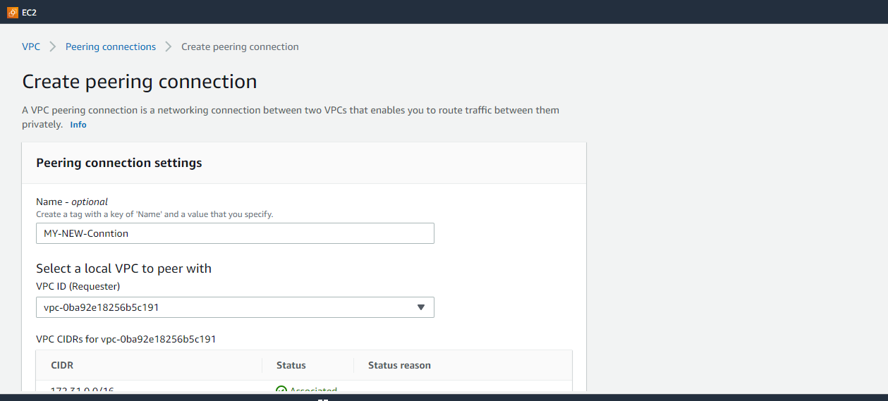

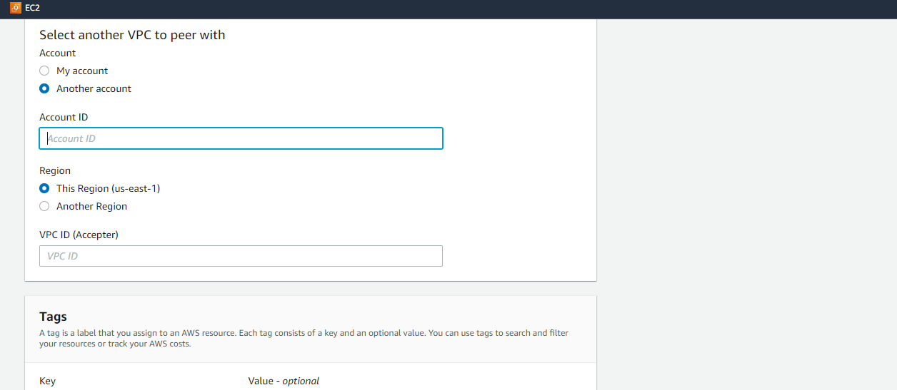

**To request a VPC peering connection with a VPC in another account in a different Region**

VPC > Create VPC Peering > VPC ID (Requester) SELECT > Another account > Account ID > Another region > SELECT region > VPC ID > create

